[](https://www.rcboe.org/rcboe)

Welcome Back! IMPACT AID Student-Parent Survey Now Available Electronically!

PARENTS/GUARDIANS…. Mark your calendar!!! October 6, 2020

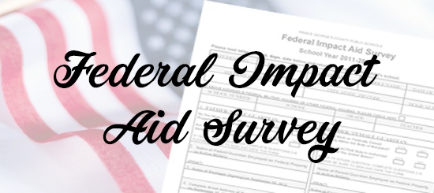

Electronic Instructions:

1. Please complete the required information on the PDF Federal Impact Aid Student-Parent Survey card.
2. Sign the electronic survey card.
3. Email the completed and signed survey card to the teacher.

Instructions to sign the survey card

1. If using a PC,

* open and download the pdf
* open the pdf in the Edge browser;
* click on the pen in the top right corner;
* sign the document
* save the document
* email the document to the teacher
* or if on a device, use your finger or a stylus

1. If using an iOS device, use the "markup" feature

[Click here](https://www.rcboe.org/Domain/16738) to view the video on how to electronically sign documents.